Hybris Installation

1. Please download the Hybris Commerce Suite 5.5.0.1 zip folder from wiki to your local desktop and extract all the folders.

Download Urls:

<https://wiki.hybris.com/display/downloads/Download>

<https://download.hybris.com/resources/releases/5.5.0/hybris-commerce-suite-5.5.0.1.zip>

For download require hybris WIKI credentials (To create credentials use cognizant email id)

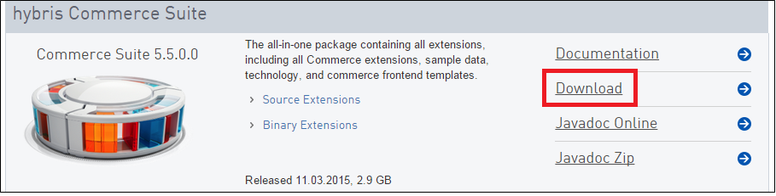

1. Unzip hybris-commerce-suite zip in local development environment.
2. If you have Unzip hybris-commerce-suite-5.4.0.1.zip then please follows below steps:
3. Ensure about JDK version installed on your computer by **java –version** command.  If you do not have a JDK installed, download the latest version of JDK 7 (min requirement) from Oracle.

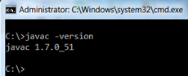

1. Set your JAVA_HOME environment variable to point to the JDK directory. See below is the PATH for set JAVA_HOME environment variable –

**PATH**: My Computer → Properties → Advanced System settings → Advanced Tab → Environmental Variables → System Variables → Add a new system variable →

**VARIABLE NAME**: - JAVA_HOME

**VARIABLE VALUE**:  <JDK installed path

1. Navigate to hybris platform folder - <YOUR HYBRIS FOLDER PATH>\bin\platform

Open project.properties in edit mode and Search for ‘tomcat.generaloptions’ and Change the below **Xmx** and **MaxPermSize** value as below.

**tomcat.generaloptions=-Xmx800M -XX:MaxPermSize=300M**

1. Add below property in <YOUR HYBRIS FOLDER PATH>\config\local.properties file

maven.update.dbdrivers=false

1. Open a command line window and navigate to <YOUR HYBRIS FOLDER PATH>/bin/platform and execute **setantenv.bat** command. Please to ensure **ant** is on your classpath
2. Execute **ant clean** command.

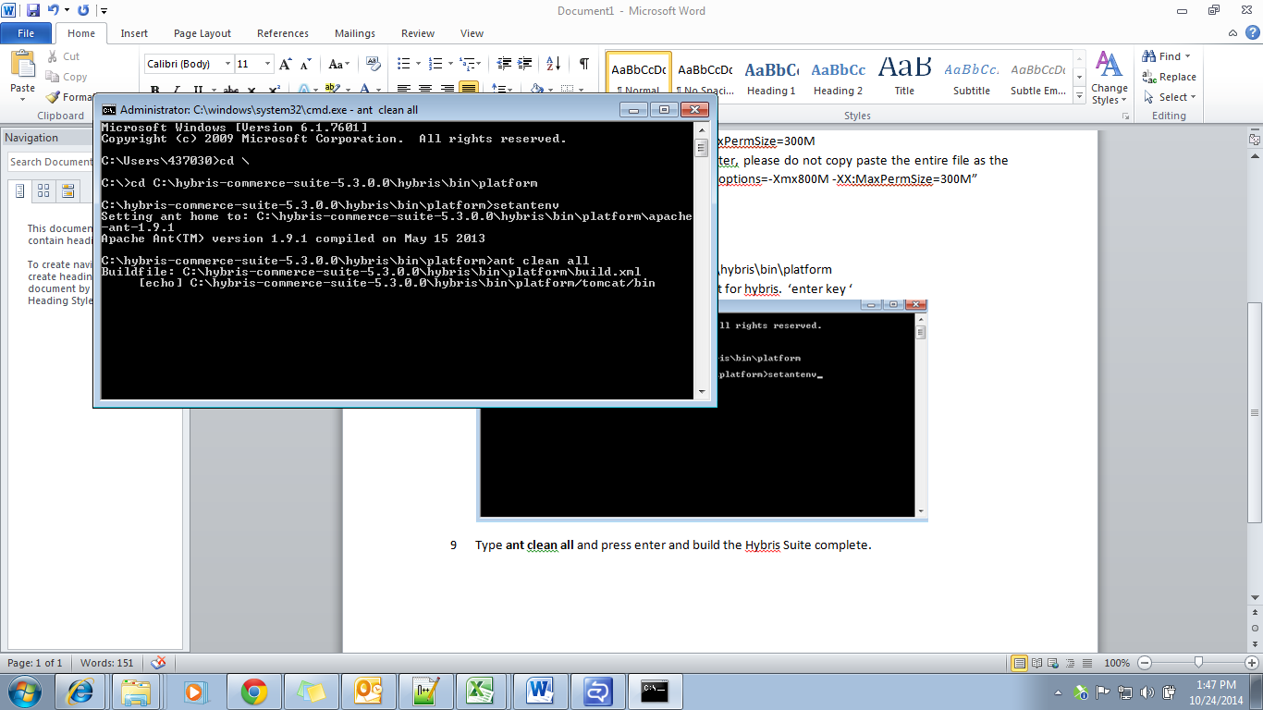

1. After you have successfully compiled, ant has created some more folders and lots of new files for you. Then starts the Hybris server by enter the command **hybrisserver.bat**.
2. After we find that, Hybris Server is started. Open in Chrome browser the hybris Administrator console. IE does not open HAC properly. URL – [**https://localhost:9001/**](https://localhost:9001/)

**login** with below credentials

**user – admin**

**password –nimda**

1. After log in to HAC. Navigate to Platform 🡪 Initialization 🡪 Click on Button ‘Initialize’. The system would take around 2 hours to initialize.

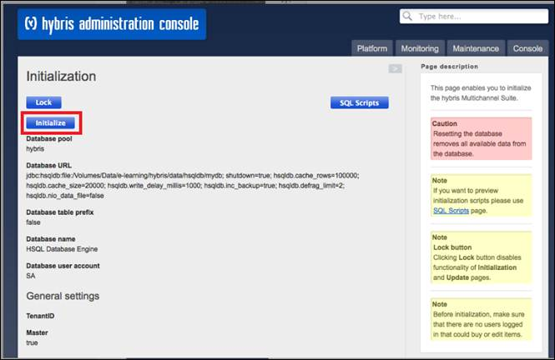

1. Once initialization is done you can check the hybris B2B and B2C sample sites provided by Hybris.
2. Add below entries in your host file for check the hybris OOB B2B and B2C sample site

127.0.0.1 apparel-de.local

127.0.0.1 electronics.local

127.0.0.1 hybris.local

127.0.0.1 apparel-uk.local

127.0.0.1 powertools.local

1. If everything is ok then stop the server - In the Command Prompt, type “CTRL + C” to stop the hybris server, and confirm Y to stop.